**1. Program for drawing different shapes using Java Applet.**

**→**

import java.applet.*;

import java.awt.*;

public class param extends Applet

{

String str;

public void init()

{

str=getParameter("pname");

if (str == null)

str = "Welcome to studytonight.com";

str = "Hello " + str;

}

public void paint(Graphics g)

{

g.drawString(str, 200, 200);

}

}

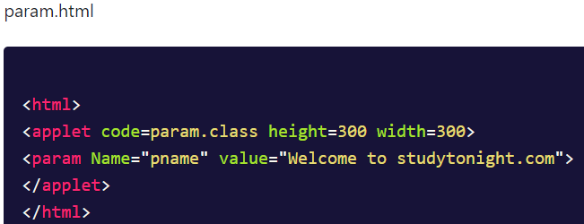

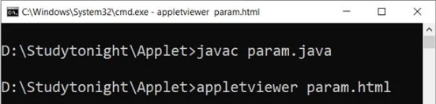

**o/p:**

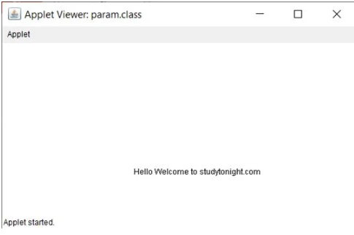

import java.applet.Applet;

import java.awt.*;

public class GraphicsDemo1 extends Applet

{

public void paint(Graphics g)

{

g.setColor(Color.black);

g.drawString("Welcome to studytonight",50, 50);

g.setColor(Color.blue); g.fillOval(170,200,30,30);

g.drawArc(90,150,30,30,30,270);

g.fillArc(270,150,30,30,0,180);

g.drawLine(21,31,20,300);

g.drawRect(70,100,30,30);

g.fillRect(170,100,30,30);

g.drawOval(70,200,30,30);

}

}

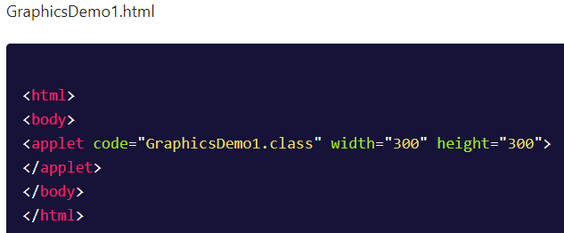

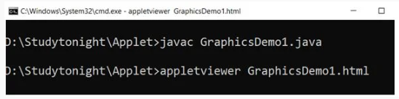

**o/p:**

